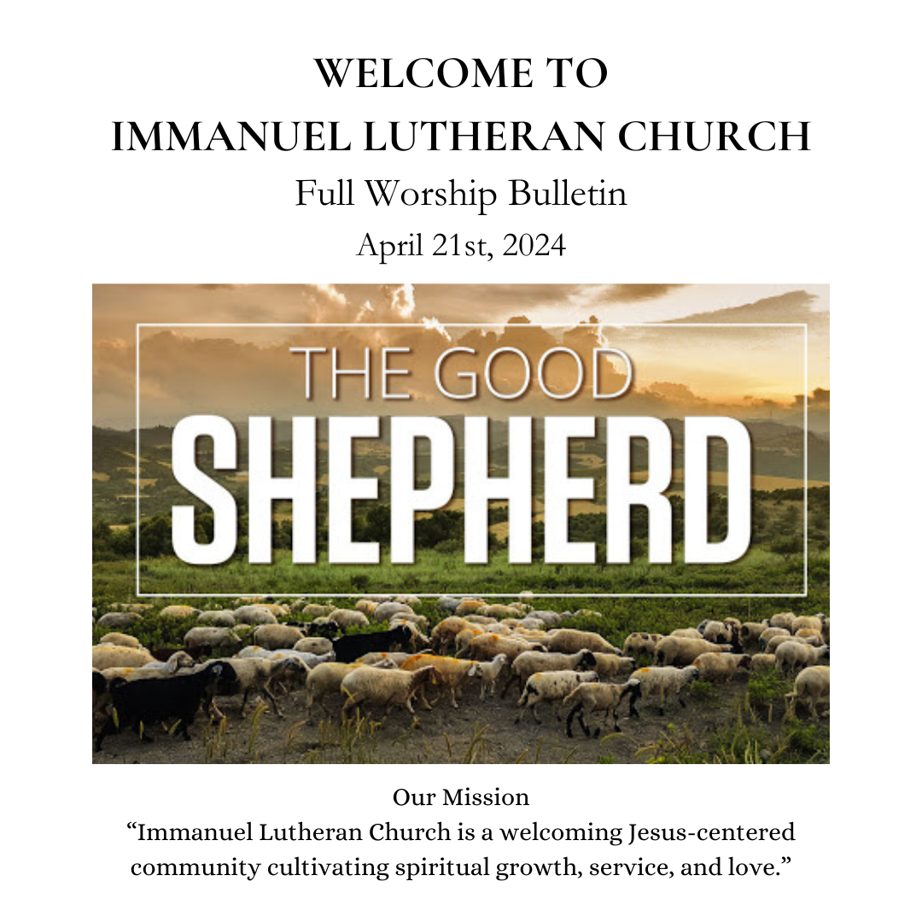

0

Welcome to
Immanuel Lutheran Church!
We welcome everyone to our service today
and hope that your experience at Immanuel is meaningful and Spirit-filled. Please take a
moment to fill out a visitor card from the slot in the pew ahead of you
and drop it in the offering plate.
Restrooms are located on the right-hand side (piano side) in the back of the church.
We also have a children’s room in the back of the church. Door to access to the room is in the back of the church and to the right-hand side (piano side).

Bold text is read by the congregation.
Music is projected on the screens.

GATHERING
The Holy Spirit calls us together as the people of God.

PRELUDE Alleluia! Sing to Jesus (Healey Willan)

WELCOME

Please rise
EASTER LITANY

The Lord Jesus Christ is our shepherd.
He lays down his life for his sheep.

The Lord Jesus Christ is our shepherd.
He knows us, and we belong to him.

The Lord Jesus Christ is our shepherd.
He speaks, and we listen for his voice.

HYMN Sing With All The Saints In Glory ELW 426 (To the tune of Ode To Joy)

1 Sing with all the saints in glory,
sing the resurrection song!
Death and sorrow, earth's dark story,
to the former days belong.
All around the clouds are breaking,
soon the storms of time shall cease;
in God's likeness we awaken,
knowing everlasting peace.

2 Oh, what glory, far exceeding
all that eye has yet perceived!
Holiest hearts for ages pleading
never that full joy conceived.
God has promised, Christ prepares it,
there on high our welcome waits.
Ev'ry humble spirit shares it,
Christ has passed the eternal gates.

3 Life eternal! heav'n rejoices:
Jesus lives who once was dead.
Shout with joy, O deathless voices!
Child of God, lift up your head!
Life eternal! Oh, what wonders
crowd on faith; what joy unknown,
when, amid earth's closing thunders,
saints shall stand before the throne!

CONFESSION AND FORGIVENESS

If we are honest with ourselves, our hearts condemn us. But God, who knows everything, is greater than our hearts; and God’s deep desire for us is mercy, love, and peace. Therefore let us confess our sin.

Lord, have mercy on us.
We talk about love, but our actions betray us.
We talk about love, but we neglect the poor.
We talk about love, but we fail to love one another.
Lord, have mercy on us.
Forgive us, and abide in us by the power of your Spirit
so that our lives may show our love for Jesus Christ,
in whose body we live and in whose name we pray. Amen

We seek God’s grace with boldness because we trust in Jesus Christ,
the One who loves us and laid down his life for us.
This is the good news of the gospel: in Jesus Christ, we are forgiven.
Thanks be to God.

GREETING
The grace of our Lord Jesus Christ, the love of God, and the communion of the
Holy Spirit be with you all.
And also with you.

PRAYER OF THE DAY
Let us pray, O Lord Christ, good shepherd of the sheep, you seek the lost and guide us into your fold. Feed us, and we shall be satisfied; heal us, and we shall be whole. Make us one with you, for you live and reign with the Father and the Holy Spirit, one God, now and forever. Amen.
WORD
God speaks to us in scripture readings, preaching, and song.

First Reading Acts 4:5-12

A reading from the book of Acts
⁵The next day [the] rulers, elders, and scribes assembled in Jerusalem, ⁶with Annas the high priest, Caiaphas, John, and Alexander, and all who were of the high-priestly family. ⁷When they had made the prisoners stand in their midst, they inquired, “By what power or by what name did you do this?” ⁸Then Peter, filled with the Holy Spirit, said to them, “Rulers of the people and elders, ⁹if we are questioned today because of a good deed done to someone who was sick and are asked how this man has been healed, ¹⁰let it be known to all of you, and to all the people of Israel, that this man is standing before you in good health by the name of Jesus Christ of Nazareth, whom you crucified, whom God raised from the dead. ¹¹This Jesus is
‘the stone that was rejected by you, the builders;
it has become the cornerstone.’
¹²There is salvation in no one else, for there is no other name under heaven given among mortals by which we must be saved.”

Word of God, Word of Life.
Thanks be to God.

SECOND READING 1 John 3:16-24

A reading from John.

¹⁶We know love by this, that [Jesus Christ] laid down his life for us—and we ought to lay down our lives for one another. ¹⁷How does God’s love abide in anyone who has the world’s goods and sees a brother or sister in need and yet refuses help?
¹⁸Little children, let us love, not in word or speech, but in truth and action. ¹⁹And by this we will know that we are from the truth and will reassure our hearts before him ²⁰whenever our hearts condemn us; for God is greater than our hearts, and he knows everything. ²¹Beloved, if our hearts do not condemn us, we have boldness before God; ²²and we receive from him whatever we ask, because we obey his commandments and do what pleases him.
²³And this is his commandment, that we should believe in the name of his Son Jesus Christ and love one another, just as he has commanded us. ²⁴All who obey his commandments abide in him, and he abides in them. And by this we know that he abides in us, by the Spirit that he has given us.

Word of God, word of life.
Thanks be to God.

CHILDREN’S MESSAGE

Please rise
GOSPEL ACCLAMATION Shepherd Me, O God ELW 780

Shepherd me, O God, beyond my wants
beyond my fears, from death into life

Gospel John 10:11-18

The holy gospel according to John

[Jesus said:] ¹¹“I am the good shepherd. The good shepherd lays down his life for the sheep. ¹²The hired hand, who is not the shepherd and does not own the sheep, sees the wolf coming and leaves the sheep and runs away—and the wolf snatches them and scatters them. ¹³The hired hand runs away because a hired hand does not care for the sheep. ¹⁴I am the good shepherd. I know my own and my own know me, ¹⁵just as the Father knows me and I know the Father. And I lay down my life for the sheep. ¹⁶I have other sheep that do not belong to this fold. I must bring them also, and they will listen to my voice. So there will be one flock, one shepherd. ¹⁷For this reason the Father loves me, because I lay down my life in order to take it up again. ¹⁸No one takes it from me, but I lay it down of my own accord. I have power to lay it down, and I have power to take it up again. I have received this command from my Father.”

The gospel of the Lord.
Praise to you, O Christ.

GOSPEL ACCLAMATION Shepherd Me, O God ELW 780

Shepherd me, O God, beyond my wants
beyond my fears, from death into life

Please be seated
SERMON

Please rise
HYMN OF THE DAY Amazed

Verse 1
You dance over me
While I am unaware
You sing all around
But I never hear the sound

Chorus
Lord I'm amazed by You
Lord I'm amazed by You
Lord I'm amazed by You
How You love me
Verse 2
You paint the morning sky
With miracles in mind
My hope will always stand
You hold me in Your hand (Chorus)

Bridge
How wide how deep
How great is Your love for me
How wide how deep
How great is Your love for me (oh) (Chorus x2)

Apostles Creed
As we celebrate Jesus’ resurrection, let us confess our faith through the words of the Apostles Creed.
I believe in God, the Father almighty,
creator of heaven and earth.
I believe in Jesus Christ, God’s only Son, our Lord,
who was conceived by the Holy Spirit,
born of the virgin Mary,
suffered under Pontius Pilate,
was crucified, died, and was buried;
he descended to the dead.
On the third day he rose again;
he ascended into heaven,
he is seated at the right hand of the Father,
and he will come to judge the living and the dead.
I believe in the Holy Spirit,
the holy catholic church,
the communion of saints,
the forgiveness of sins,
the resurrection of the body,
and the life everlasting. Amen.

PRAYERS of Intercession
At the end of each petition, the reader will say, “God of grace,” and please respond with, “Hear our prayer.”
Prayers begin
Rejoicing that Jesus is risen and love has triumphed over fear, let us pray for the church, the world, and all those in need of good news.

The prayers conclude:
Into your hands, most merciful God, we commend all for whom we pray, trusting in your abiding love; through Jesus Christ, our resurrected and living Lord. Amen.

Peace
The peace of the Resurrected Christ be with you always.
And also with you.
Please share signs of peace with one another.

Please be seated
ANNOUNCEMENTS

Offering
Everyone is invited to make an offering as an expression of gratitude for God’s generosity.
The user will pass the plate, or you may give using the QR code.

OFFERTORY HYMN His Sheep Am I

Verse
In God’s green pastures feeding,
by His cool waters lie -
Soft in the evening walk my Lord and I:
All the sheep of His pasture fare so wondrously fine
His sheep am I.
Waters cool, pastures green,
In the evening walk my Lord and I;
Dark the night, rough the way -
Step by step, my Lord and I. (Repeat)

Ending
In God’s green pastures feeding,
by His cool waters lie -
Soft in the evening walk my Lord and I:
All the sheep of His pasture fare so wondrously fine
His sheep am I.

OFFERTORY PRAYER
Let us pray, Risen One, you call us to believe and bear fruit. May the gifts that we offer here be signs of your abiding love. Form us to be your witnesses in the world, through Jesus Christ, our true vine. Amen.

MEAL
God feeds us with the presence of Jesus Christ.

THANKSGIVING AT THE TABLE

The Lord be with you.
And also with you.

Lift up your hearts.
We lift them to the Lord.

Let us give thanks to the Lord our God.
It is right to give God thanks and praise.

EUCHARISTIC PRAYER

Lord’s Prayer
Lord, remember us in your love and teach us to pray.
Our Father, who art in heaven,
hallowed be thy name,
thy kingdom come,
thy will be done,
on earth as it is in heaven.
Give us this day our daily bread;
and forgive us our trespasses,
as we forgive those
who trespass against us;
and lead us not into temptation,
but deliver us from evil.
For thine is the kingdom,
and the power, and the glory,
forever and ever. Amen

Invitation to Communion
Come, for all is ready, and all are welcome. Taste and see that the Lord is good.

Please be seated
COMMUNION
All are welcome to commune at Christ’s Holy Supper. We invite everyone to come forward to the altar to receive the Body and Blood of Christ. As you come forward by way of the center aisle, the usher will hand you an empty cup. You will receive the wafer first, then you can choose to have your cup filled with either wine or grape juice. The wine cup is closest to the pastor. Please place your empty cup in the basket as you return to your seat by way of the side aisle. If you cannot come forward to receive communion but would like to receive it directly from the pastor, please let an usher know and the pastor will bring communion to you. Gluten-free wafers are available as well. Children and adults who do not receive communion are invited to come forward as they wish to receive a blessing.

Communion Song He Leadeth Me LBW 501

1 He leadeth me: oh, blessed thought!
Oh, words with heav’nly comfort fraught!
Whate’er I do, where’er I be,
still ’tis God’s hand that leadeth me.

Refrain
He leadeth me, he leadeth me,
by his own hand he leadeth me.
His faithful foll’wer I would be,
for by his hand he leadeth me.

2 Sometimes mid scenes of deepest gloom,
sometimes where Eden’s bowers bloom,
by waters calm, o’er troubled sea,
still ’tis God’s hand that leadeth me. (Refrain)

3 Lord, I would clasp thy hand in mine,
nor ever murmur nor repine;
content, whatever lot I see,
since ’tis my God that leadeth me. (Refrain)

4 And when my task on earth is done,
when by thy grace the vict’ry’s won,
e’en death’s cold wave I will not flee,
since God through Jordan leadeth me. (Refrain)

Ending
for by his hand he leadeth me.

Please rise
POST-COMMUNION BLESSING
The body and blood of our Lord Jesus Christ strengthen you and keep you in his grace.
Amen.

Post-Communion Prayer
Let us pray, shepherding God, you have prepared a table before us and nourished us with your love. Send us forth from this banquet to proclaim your goodness and share the abundant mercy of Jesus, our redeemer and friend. Amen.

SENDING
The Holy Spirit leads us out into the world.

BLESSING

The God of resurrection power, the Christ of unending joy, and the Spirit of Easter hope ☩ bless you now and always.
Amen.

SENDING HYMN Raise A Hallelujah

Verse 1
I raise a hallelujah in the presence of my enemies
I raise a hallelujah louder than the unbelief
I raise a hallelujah my weapon is a melody
I raise a hallelujah Heaven comes to fight for me

Chorus
I’m gonna sing in the middle of the storm
Louder and louder you’re gonna hear my praises roar
Up from the ashes hope will arise
Death is defeated the King is alive

Verse 2
I raise a hallelujah with everything inside of me
I raise a hallelujah I will watch the darkness flee
I raise a hallelujah in the middle of the mystery
I raise a hallelujah fear you lost your hold on me (Chorus)

Bridge
Sing a little louder (Sing a little louder)
Sing a little louder (Sing a little louder)
Sing a little louder (Sing a little louder)
Sing a little louder (Sing a little louder)

Bridge
Sing a little louder in the presence of my enemies
Sing a little louder louder than the unbelief
Sing a little louder my weapon is a melody
Sing a little louder Heaven comes to fight for me

Sing a little louder

Ending
I raise a hallelujah
I raise a hallelujah
I raise a hallelujah
I raise a hallelujah

DISMISSAL

Alleluia! Go in peace. Rejoice and be glad.
Thanks be to God. Alleluia!

POSTLUDE My Shepherd Will Supply My Need (Robert Hobby)

Thank you for joining us in worship today!
We hope that your experience at Immanuel is meaningful and Spirit-filled.
Before you leave, please take a moment to fill out a
visitor card from the slot in the pew ahead of you.
If you have questions, request more information about Immanuel Lutheran Church, or wish to speak to the pastor, you can call the church office or email the Pastor anytime.

Acknowledgments
From Sundays and Seasons.com. Copyright 2015 Augsburg Fortress. All rights reserved. Reprinted by permission under Augsburg Fortress Liturgies Annual License # SAS004138. New Revised Standard Version Bible, Copyright © 1989, Division of Christian Education of the National Council of the Churches of Christ in the United States of America. Used by permission. All rights reserved. Revised Common Lectionary, Copyright © 1992 Consultation on Common Texts, admin Augsburg Fortress. OneLicense #A-706353
Amazed Jared Anderson © 2004 Integrity Worship Music (Admin. by Integrity Music) CCLI License # 996388
He Leadeth Me Public Domain
His Sheep Am I © Orien Johnson 1984 Word Music, LLC (a division of Word Music Group, Inc.) CCLI License # 996388
Raise A Hallelujah Jake Stevens, Jonathan David Helser, Melissa Helser, Molly Skaggs2018 Bethel Music Publishing CCLI#: 996388
Shepherd Me, O God Marty Haugen, b. 1950, based on Psalm 23 Text © 1986 GIA Publications, Inc., 7404 S. Mason Ave., Chicago, IL 60638 OneLicense # A-706353
Sing with All the Saints in Glory Augsburg Fortress P.O. Box 1209 Minneapolis, MN 55440 OneLicense # A-706353, CCLI License # 996388

Thank you to those serving at Immanuel’s 10 am Service Today
Video Livestream/Projection:
Altar Care:
Reader: Chad Stearns
Assisting Minister: Bill & Julie Boardman
Communion Assistants: Chad Stearns
Greeters / Open-Close Church:
Coffee Host:
Banking Team: Kim Jackson, Dolores Fuller
Praise Singers and Musicians: Julie and Bill Boardman, Margo Lee (drums)
Winnie Manners, Matt Peters (guitar), Priscilla and Steve Repetti, Kurt McLachlan,
Joe Roark (keyboard), Melody Wright Bast (organist)
Ed Johnson (Praise Team Director), Hank Ford (bass guitar)

Immanuel Lutheran Church
1715 Grant Rd, Los Altos, CA 95014
Rev: Josh Martyn pastorjosh@ilclosaltos.com, 563-613-4337
Youth Minister: Danny Dye, 650-861-1093
Office Manager: Naka Terry 650-967-4906
Praise Team Director: Ed Johnson
Organist: Melody Wright Bast, pianowithmelody@gmail.com
Visitor Communications: Lynn North, l.north@theagencyre.com
Church Office: 650-967-4906, office@ilclosaltos.com
Council Members: Tom Hampton (President), Winnie Manners (Vice President),
Perry Peterson (Treasurer), Jennifer Urmson (Secretary), Chad Stearns, Gisela Daetz, Hank Ford, Paul Dhuse, Rhett Livengood, Lynn North, Kendall Hofstetter, and Pastor Josh Martyn

